Unit 13 – Chemical Bonding
(Sections: 6.2, 6.5, 10.1-10.3)

I Can Statements:

(10.1) Electron-Dot Formulas
1. I can explain why atoms are bonded to other atoms.
2. I can discuss the properties of ionic and covalent bonds.
3. I can use chemical formulas and Lewis structure to represent compounds.
A. I can draw an electron dot diagram for any neutral element, ion, or compound
B. I can use these models to visualize atoms and molecules and predict the properties of substances
C. State and explain the octet rule
D. Correctly identify elements that are exceptions to the octet rule and state whether those elements
are stable with less than an octet or with an expanded octet.
E. Explain the difference between a Lewis Structure and an electron-dot structures
F. Distinguish between lone pairs and bonding pairs of electrons in a Lewis Structure
G. I can use Lewis structures to represent covalent compounds using a simple set of rules
- Determine the total number of valence electrons for each element in the compound
- Determine the central atom in the compound
- Determine the arrangement of the other atoms around the central atom
- Determine the number of bonds on the central atom
- Determine when multiple bonds are necessary
- Determine the number of lone pairs on all the atoms in the compound

(10.2) VSEPR Theory
4. I can use Lewis structures and valence shell electron pair repulsion (VSEPR) theory to predict the three-
dimensional electron pair and molecular geometries of compounds.
A. Explain the VSEPR Theory
B. Name the 5 Electron Domains
C. Recognize the number of electrons domains around the central atom for any given Lewis Structure
D. Determine the any Molecular Geometry for the first 3 electron domains
E. Determine the molecular geometry for a Lewis Structure with 5 or 6 electron domains
F. Determine the Bond Angle for any bond in the first 3 electron domains

(10.3) Electronegativity and Polarity
5. I can explain the concepts of Electronegativity and Polarity as they relate to ionic and covalent bonds
A. Use electronegativity to predict Bond Polarity
B. Explain the term Dipole and use the magnitude of the bond dipole to determine the bond polarity
- nonpolar covalent
- polar covalent
C. Use molecular geometry and bond dipoles to determine Molecular Polarity

Vocabulary:

Bond Angle
Bonded Pair
Bond Polarity
Covalent Bonds
Double Bond
Electron Domain
Electron-dot
Electronegativity (E_{N})
Ionic Bond
Lewis Structure
Linear
Lone Pair
Molecular Geometry
Molecular Polarity
Multiple Bonds
Octahedral
Octet Rule
Polarity
Single Bond
Trigonal
Triple Bond
Tetrahedral
Trigonal Bipyramidal
VSEPR Theory

Achievement Scale:
Goal | C Level | B Level | A Level
10.1  Electron-Dot Formulas | - Can determine and draw an electron-dot structure for any neutral element, monatomic ion, or binary ionic compound  - Can explain the difference between ionic and covalent bonding  - Can state and explain the octet rule  - Can distinguish between lone pairs and bonding pairs in a Lewis Structure  - Can determine the number of valence electrons that should be drawn on a Lewis Structure.  - Can determine which atom(s) in a chemical formula should be the central atom in a Lewis Structure.  - Can accommodate all valance electrons on a structure using single, double and triple bonds. | - Can choose the correctly drawn Lewis structure from a set of possible Lewis Structure. | - Can draw a Lewis structure for a given covalent compound.
10.2  VSEPR Theory | - Can explain the VSEPR Theory  - Can recognize the number of electron domains around the central atom for a given Lewis Structure  - Can recognize and identify molecules all electron domain geometries when given a Lewis Structure. | - Can use a chart to determine the molecular geometry for any Lewis Structure with 5 or 6 electron domains.  - Can determine the molecular geometry for the first 3 electron domains. | - Draw the Lewis Structure of a given covalent compound with the correct spatial molecular geometry.
10.3  Electro-negativty and Polarity | - Can explain how the concept of electronegativity relates to the polarity of a bond  - Can explain the term polarity as it relates to ionic and covalent bonds  - Can use electronegativity to predict the polarity of a bond  - Can use molecular geometry and bond dipoles to determine the polarity of a molecule.
Sample Questions:

1. Draw the Lewis Structure for CO₂

(a) Is this a covalent or an ionic compound? Explain.

COVALENT; the electrons are being SHARED b/c the difference in E_{N} between carbon and oxygen means the bonds have only ≈ 25.9 % ionic characteristic

(b) How many lone pairs are on the central atom of this molecule? Zero
(c) How many bonding pairs? 4

2. Draw all possible Lewis structures for ozone, O₃

(a) Does the ozone molecule have resonance? Explain.

YES; the single and double bonds are interchangeable

3. What does VSEPR stand for? Valence Shell Electron-Pair Repulsion

4. Answer the following questions based on the Lewis Structure for water shown below:
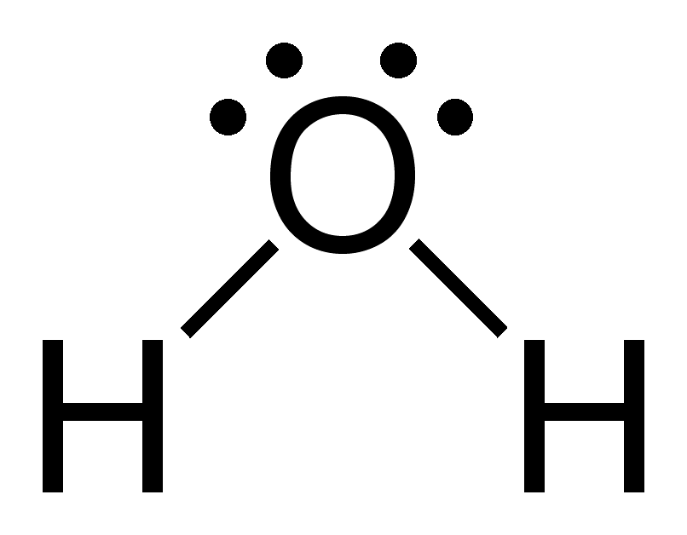
(a) How many electron domains are there around the central atom? 4
(b) What is the electron-domain geometry for this molecule. Tetrahedral
(c) What is the molecular geometry for this molecule? Bent
(d) Determine if the O─H bond is nonpolar, polar covalent, or ionic. Polar covalent
(e) Draw the bond dipoles on this molecule.
(f) Is the molecule polar? Explain. YES, the direction of the bond dipoles is “additive”

